Voting in a federal election
Polling place
A SOCIAL STORY

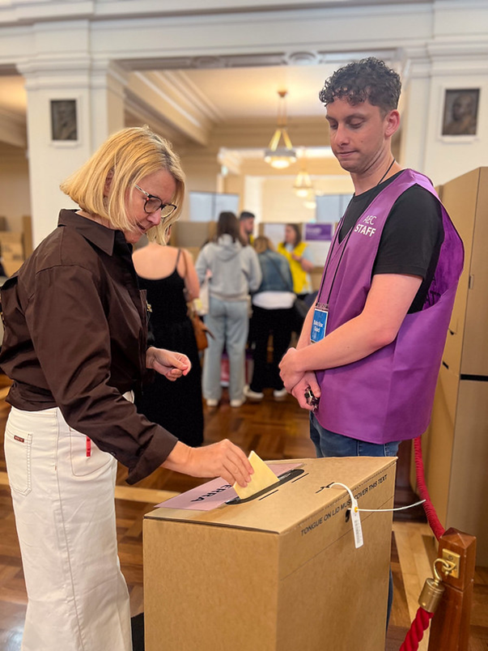
On election day, I will vote.
When I vote, I help to choose who is part of Australia’s government.
The government makes decisions on our behalf about how to run the country.
It’s important for me to have a say about who makes the decisions that affect me.
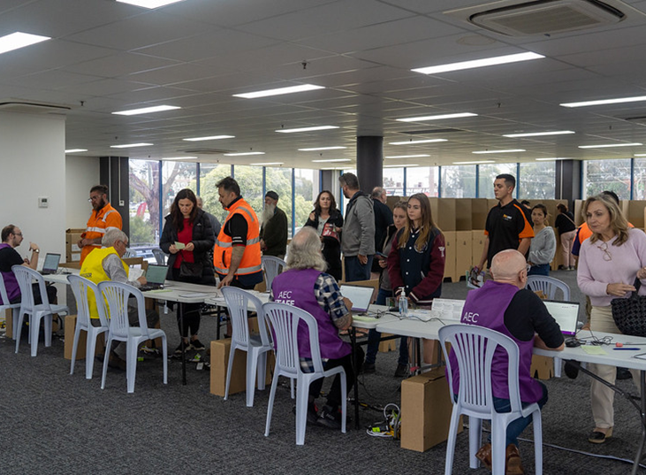

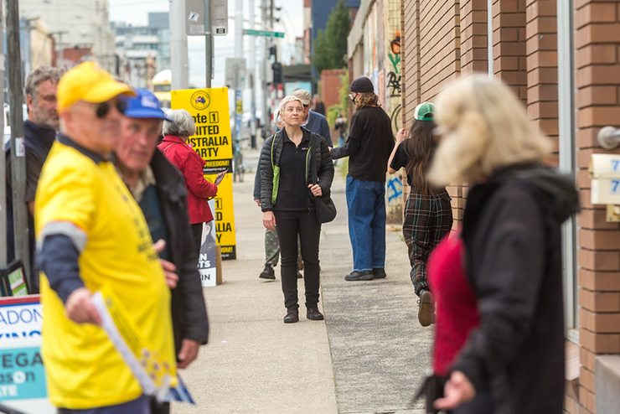

For me to make the best choice possible I can research the candidates or get advice from someone I trust.
My vote is secret. It’s my choice who I vote for, and I don’t need to tell anyone how I voted unless I want to.

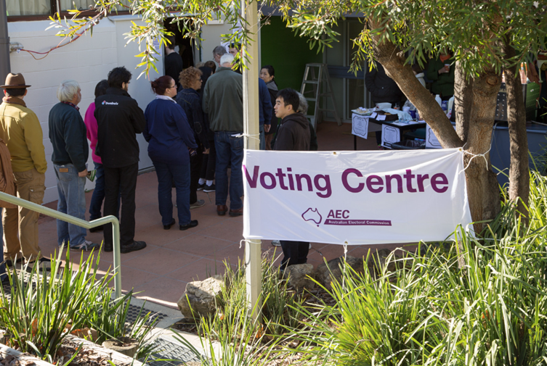

On election day, I will go to a polling place.
When I arrive at the polling place there might be a lot of people, and I might need to wait in a line.



It might be very noisy, and I might want to take ear plugs, headphones or a support person to help me.

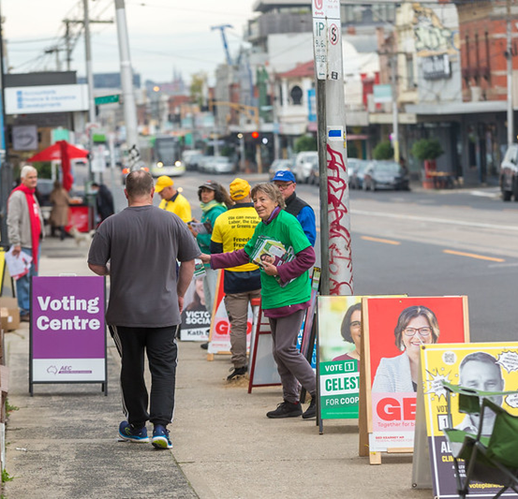
I might see people handing out pieces of paper. These pieces of paper explain how I might like to vote for a particular party.

I don’t have to take one if I don’t want to.

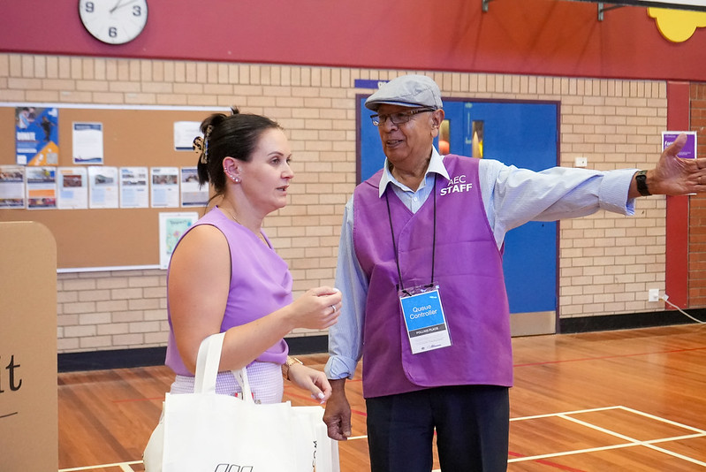
The Australian Electoral Commission, or AEC, is responsible for running the election.
When I go inside, I will speak to an AEC staff member in a purple vest with a lanyard around their neck. I can ask someone to help me at any time.

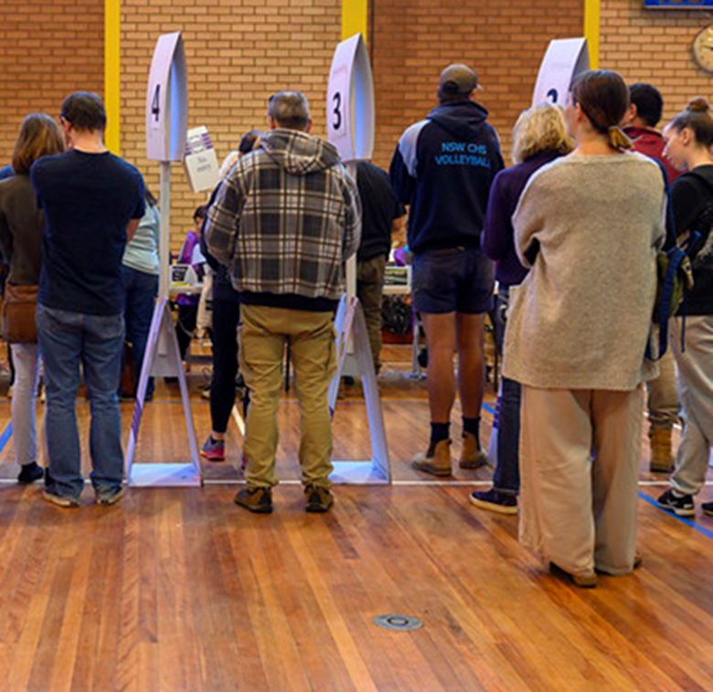

I might need to line up and wait for my turn before I get to vote.

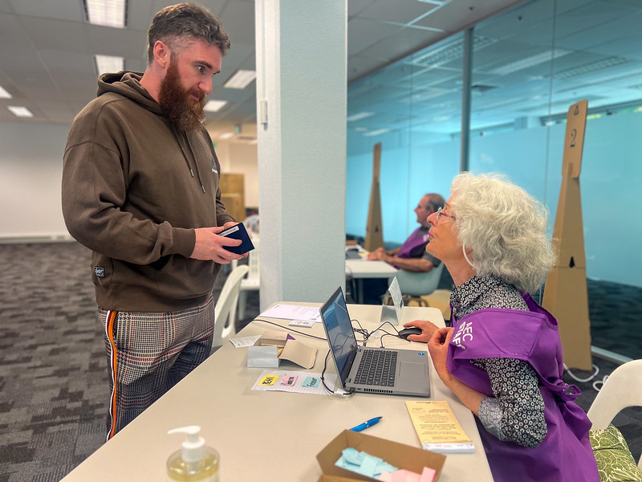

The staff member will help me find the table where I will speak to another AEC staff member.

This person will ask me 3 questions so they can find my name on the list.

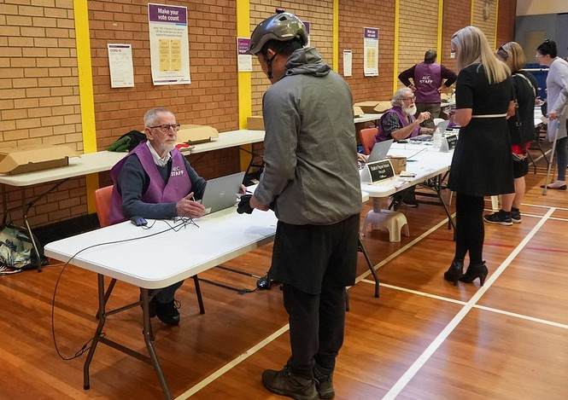

First, they will ask,
“What is your name?”
I need to tell them my first and last name.

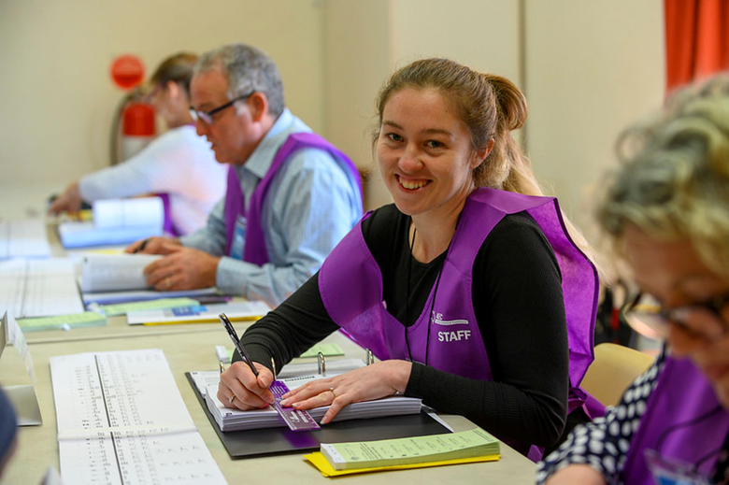

Next, they will ask,
“What is your address?”
I need to tell them the address I gave when I enrolled to vote. This address will probably be where I live.

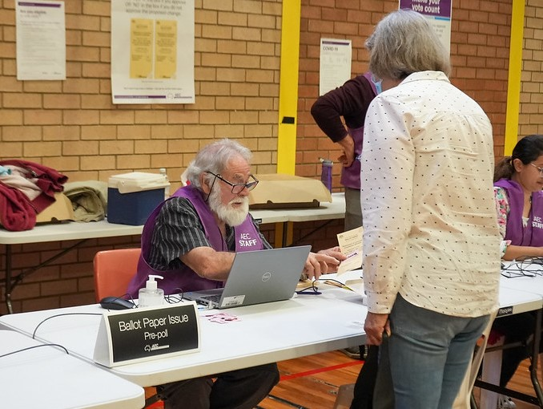

The third question they will ask is, “Have you voted before in this election?”
I need to say “No” if I haven’t voted in this election. I need to say “Yes” if I have already voted in this election.

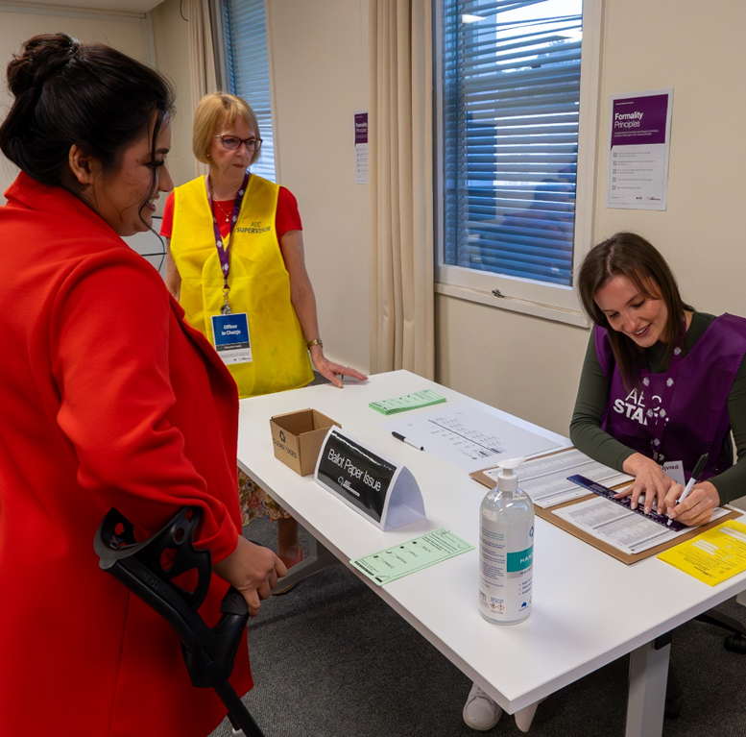

The AEC staff member will cross my name off the list.

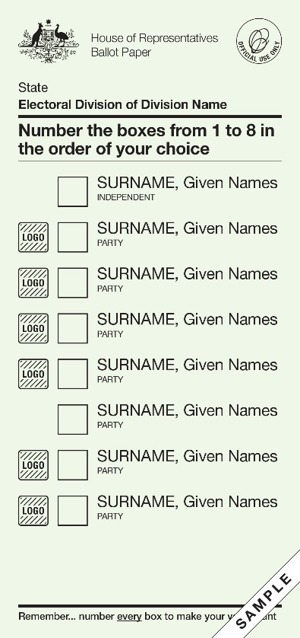

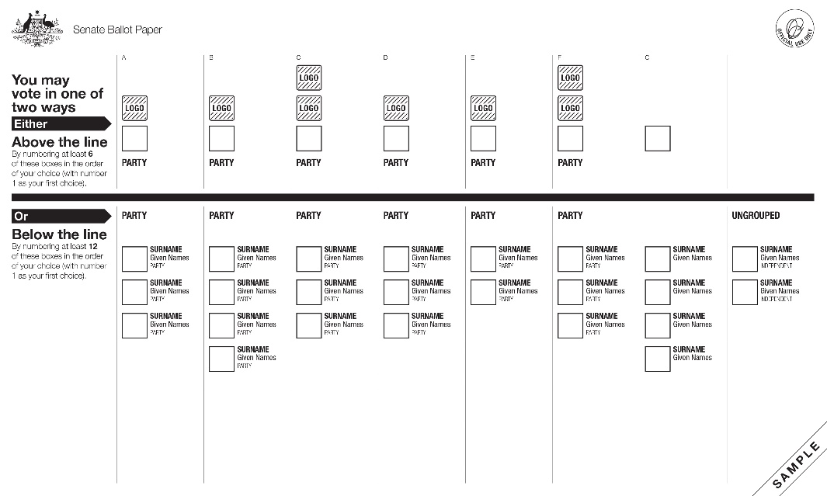

I will be given 2 ballot papers.

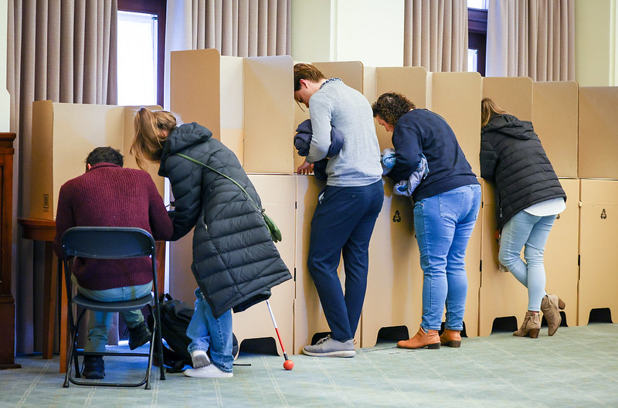
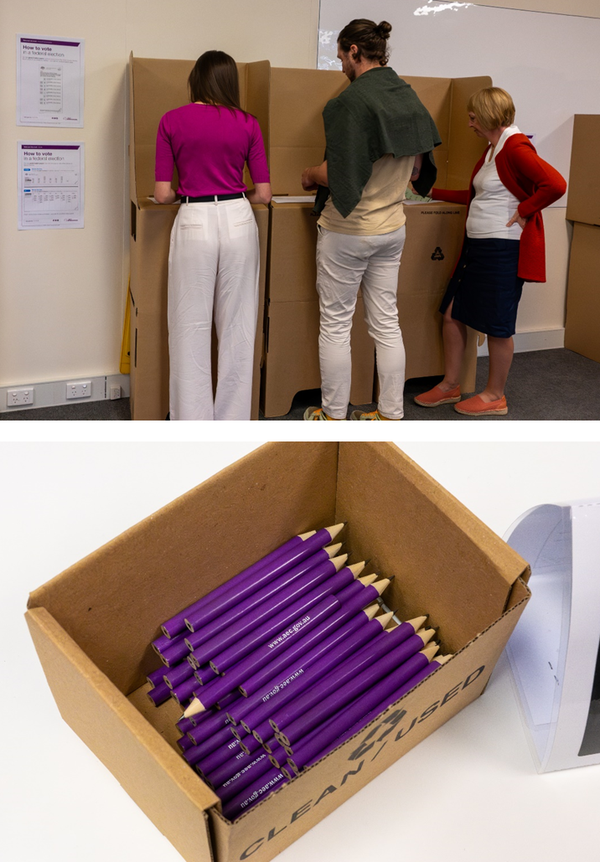
I need to take my ballot papers to the voting tables.
I will be given a pencil to fill out the ballot papers. I can also bring and use my own pen or pencil if I want to.

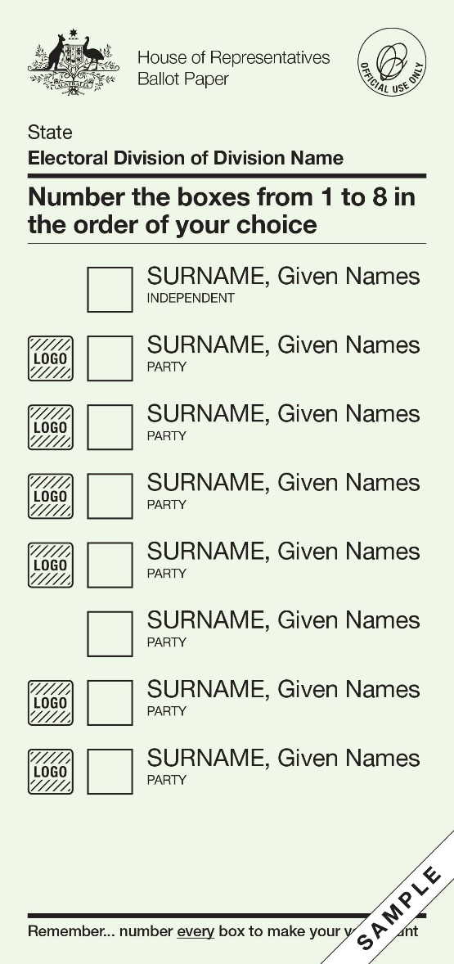

The green ballot paper is for the House of Representatives, and it has a list of all the candidates I can vote for.

A candidate is a person who wants to be part of the Parliament.

If the candidate belongs to a political party, it will be written under their name.
On the green ballot paper, I need to write 1 in the box next to my favourite candidate, then 2 in the box for my second favourite.
There are instructions on the ballot paper telling me how many numbers to write.
I need to keep writing numbers until all the boxes are filled.

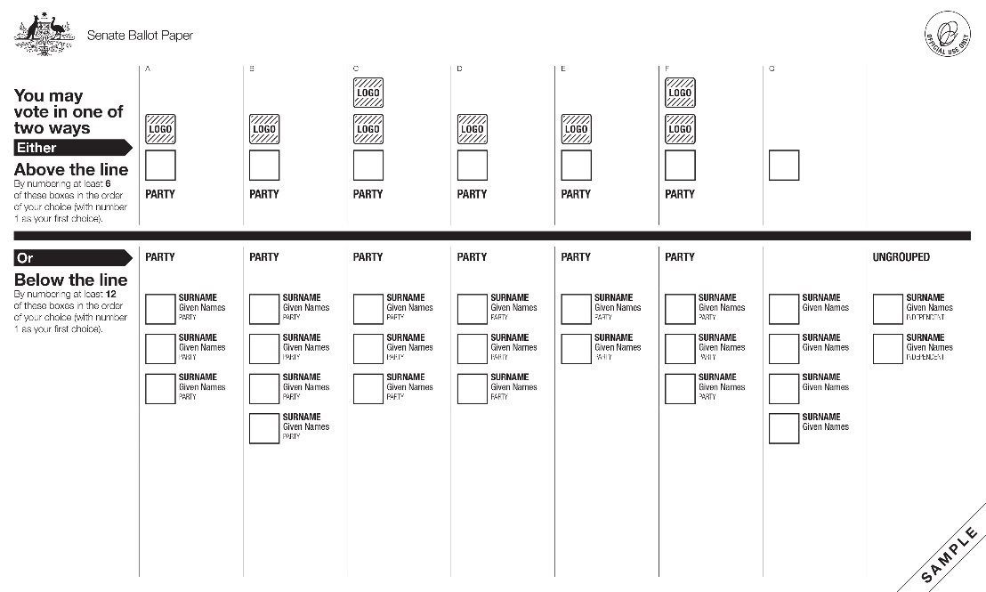

The white ballot paper is for the Senate, and it has a list of all the candidates I can vote for.

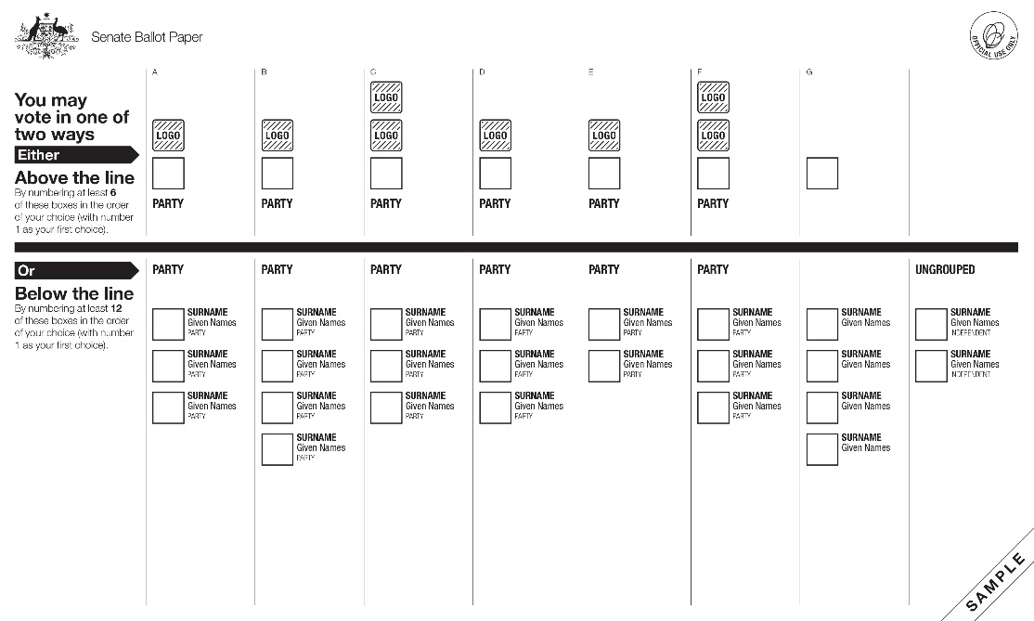
There is a list of groups above the black line.
Most of the groups are political parties.
A political party is a group of people who:
- share some of the same ideas
- work together on a plan for how government should run our country.
There is a list of candidates below the black line.
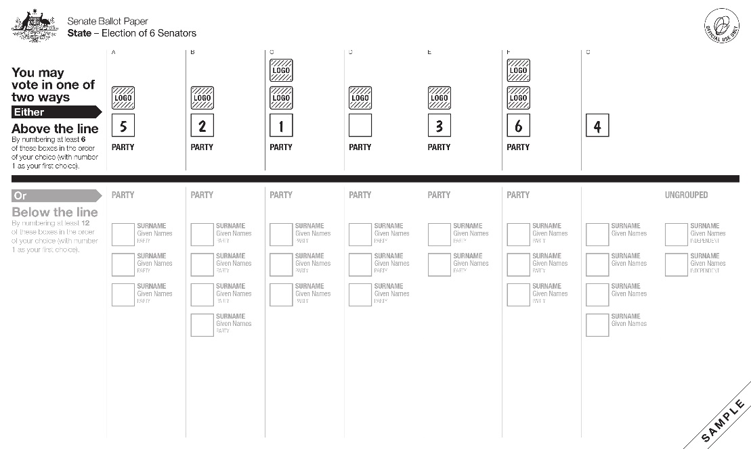
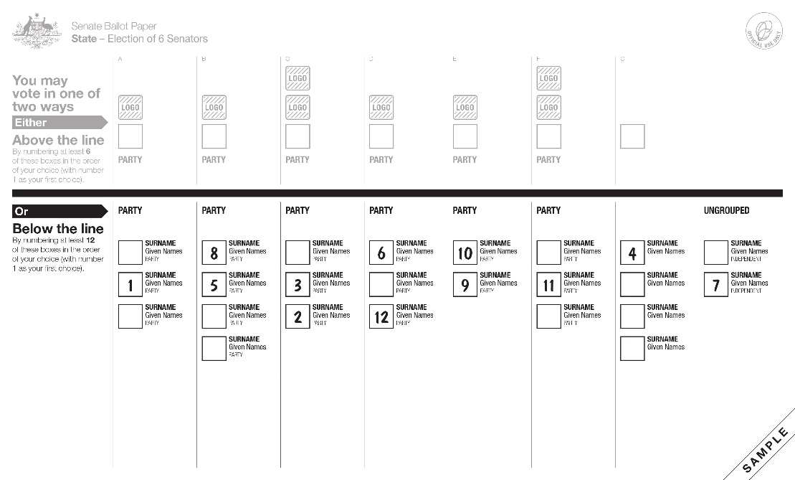

There are two ways I can vote. I get to choose.
I can vote above the line and vote for groups or political parties.
Or
I can vote below the line and vote for candidates.
I should read and follow the instructions on the ballot paper carefully to make sure my vote counts.

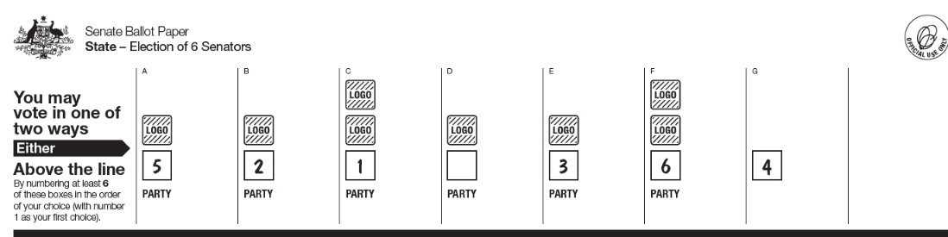
Write numbers 1–6
1 = my favourite
To vote above the line, I can put numbers in the boxes above the black line.
I will write a number 1 in the box for my favourite group, then 2 in the box for my second favourite.
I need to keep going until I have written numbers 1, 2, 3, 4, 5 and 6.
I can finish at 6 or keep going and write numbers in as many boxes above the line as I like.

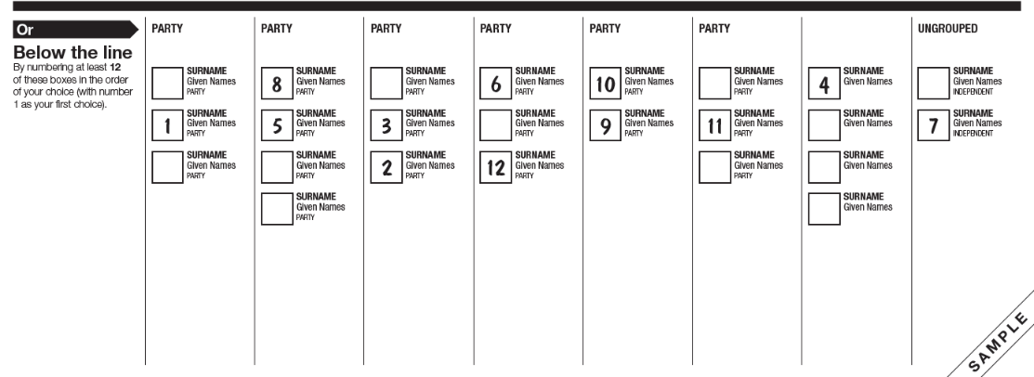
Write numbers 1–12
1 = my favourite
To vote below the line, I can put numbers in the boxes below the black line.
I will write 1 in the box next to my favourite candidate, then 2 in the box for my second favourite.
I need to keep going until I have written numbers 1 to 12.
I can finish at 12 or I can keep going and write numbers in as many boxes below the line as I like.
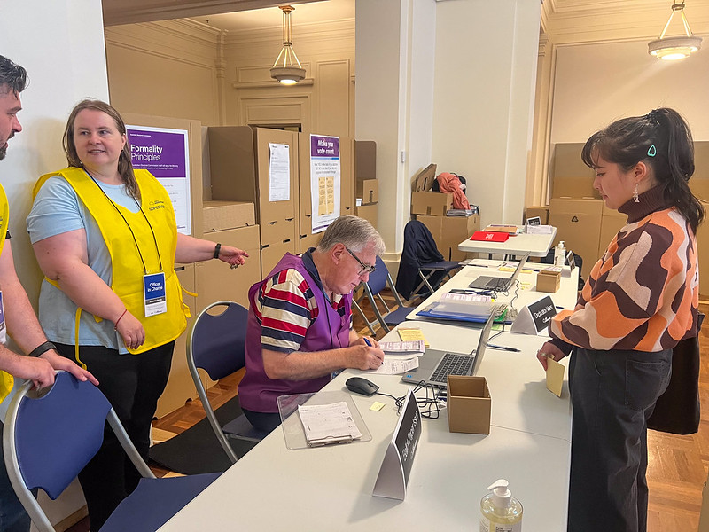
If I need help, I can ask one of the AEC staff or a friend or family member
If I make a mistake on my ballot papers, I can take them back to the AEC staff member who gave them to me.

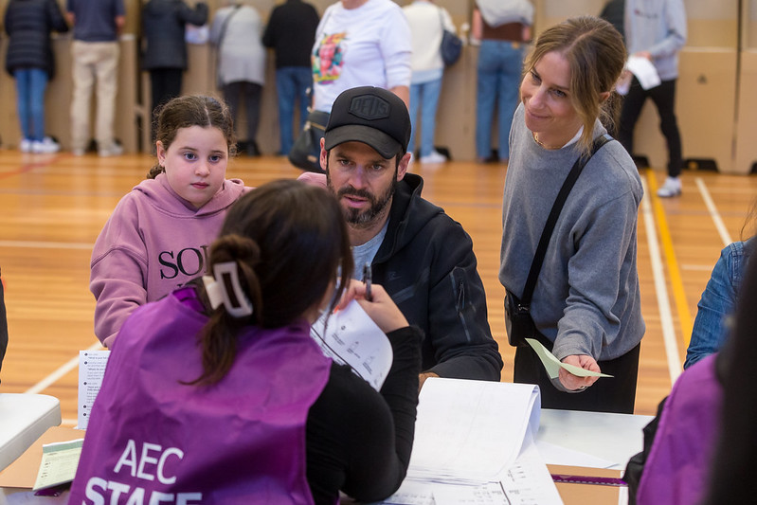

I can tell them I made a mistake and need a new ballot paper.
The AEC staff will:
- take the ballot paper with the mistake
- give me a new one
I will take the new ballot paper and fill it out.

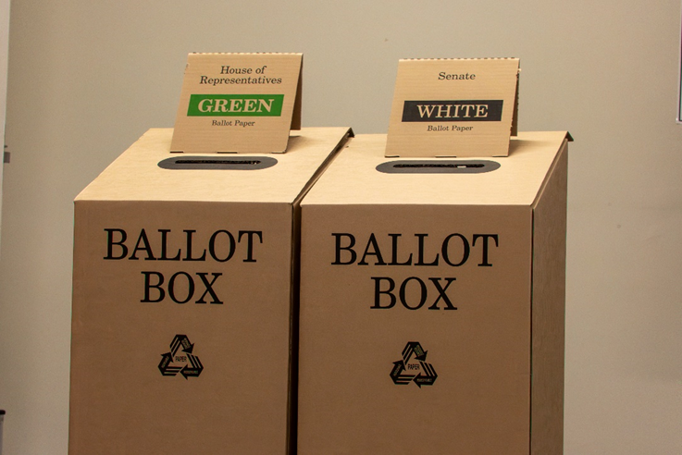

When I have voted I need to put my ballot papers in the ballot boxes.
There is one box for the green ballot paper and one box for the white ballot paper.

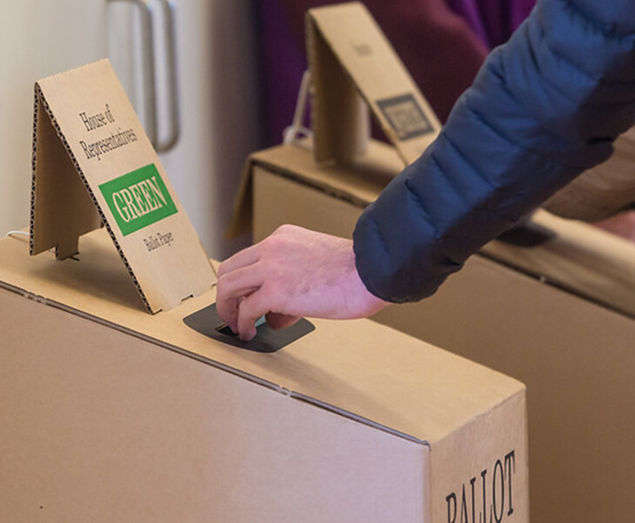

I will put my green ballot paper in the box that says: Green.
I will put my white ballot paper in the box that says: White.

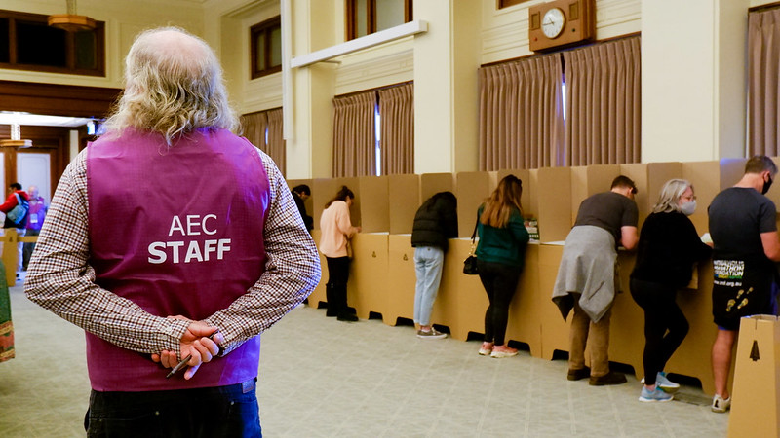

The AEC staff member can help show me which boxes to put my ballot papers in.

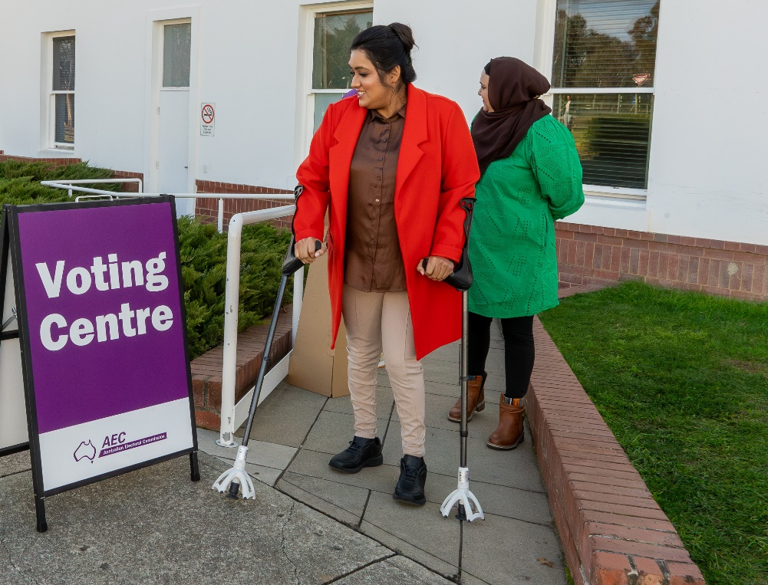

Now I have finished voting and I can leave.

